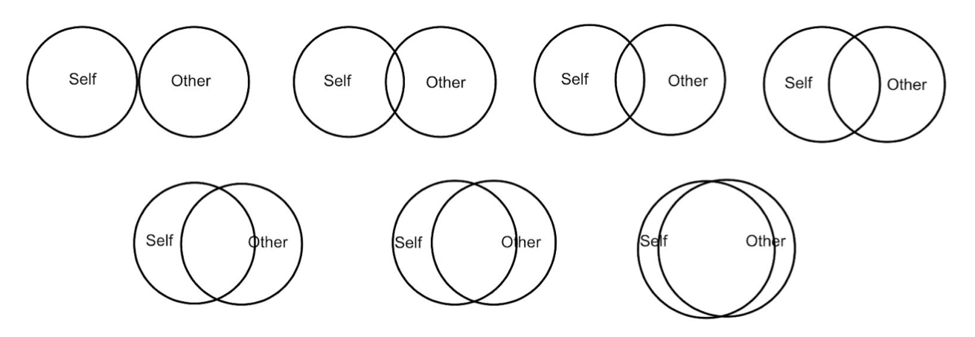

Team

Self

Self

Team

Self

Team

Self

Team

Self

Team

Team

Self

Team

Self